Study area

The Hacienda Aquiares is the largest coffee plantation in Costa Rica, covering around 924 hectares, of which 673 are cultivated with (shade-grown) Arabica coffee. The farm is located in between the Pacific Ocean (+- 70 km) and the Atlantic Ocean (+- 55 km). More important factors in the area are the vicinity of the Turrialba Volcano, which is 3,340 m and which peak is only located around 7 km from the upper parts of the farm (close to 12 km from the lower parts). The farm starts just above 800m and continues to close to 1400 meters. The lowest sensors in this study has been placed at 832 meters and the heighest at 1399 meters, giving a more than 500 meter altitude range to study. Coffee quality associated with a certain altitude, which will relative to the prevailing climate (temperature, radiation & humidity) and possibly to the different soils at the higher altitudes. The coffee with the best quality at the Hacienda Aquires is considered to be located > 1100 meter. This is around 45% of the area, but estimated to only suppy 31% of the crop; this is likely the result of the natural areas that can also be found at the higher altitudes, where the inclination of the terrain is generally also steeper. The presence of natural areas can be seen in a map of the Leaf Area Index (LAI) of the farm (figure 1), in which areas in the upper regions often have values that can be associated with that of forest. The spatial distribution of sensors over the factors that are expected to play a possible role (altitude, leaf area index, vegetation height and soil?) are provided in Annex 1. Original sampling was based on a hexagonal grid inside a watershed of the farm (n = 50), while the other 50 samples were calculated by adding two points to 25 strata's of the study area. In the end, the bad all weather made it difficult to reach all points, which led to an assessment (together with local farmers) of other suitable locations. The number of points at different levels (50 in the watershed & 50 in the farm) has remained the same.

Figure 1: Leaf Area Index (LAI) in the Hacienda Aquiares
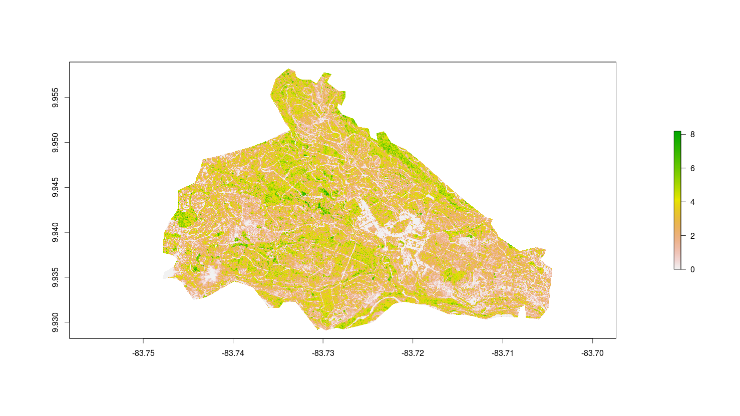
Annex 1: Spatial distribution of sample points over different co-variables

Sampling in Aquiares – Altitude (m)

The tower with the weather station is located at an altitude of just over around 1050 meter, which has resulted in the large amount of samples in the 1050-1100 altitude segment. The samples at farm-level (n = 50) are well-distributed over the different altitude segments. The farm fits within the range that is normally considered best for Arabica coffee, with most of the area being between 1000-1200m. There is a posive link between altitude and many characteristics of coffee, which will be linked to the climatic data in this study. The town of Aquiares is located just below the watershed (+- 900-1050m), which can explain the relatively low amount of coffee that is being cultivated at this altitude segment. In the shapefile used for the leaf area index (LAI), urban areas are included, as they impact on LAI.
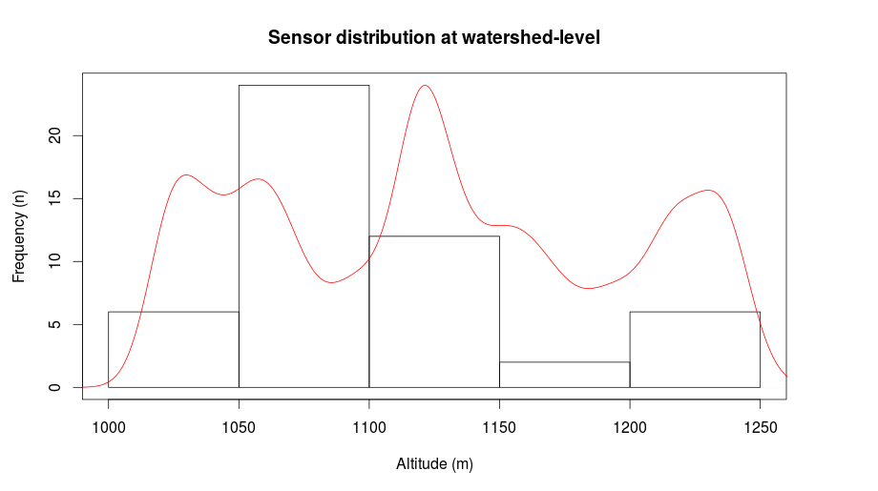
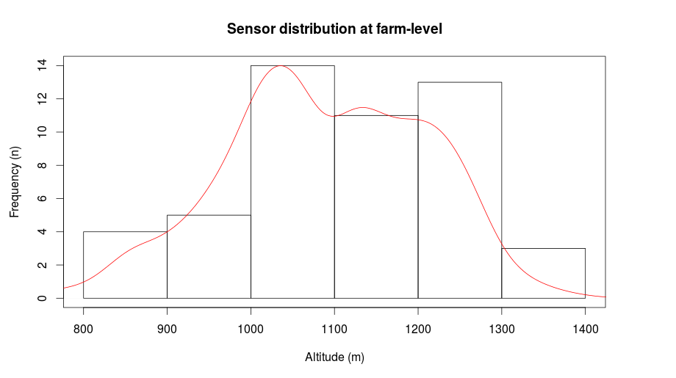
Sampling in Aquiares – Leaf Area Index (LAI)

The minimum LAI in the Aquiares area (including the town) is 2.49, with a minimum value of 0 and a maximum value of 8.89. The mean LAI has been calculated in a 25m buffer around the observation, which resulted in a mean of 2.48 for all 100 samples, a min of 0.68 and a max of 4.19. The 'extremes', which are found in the fully natural (0) and urban areas (> 5) are not included in the observations. The density curve shows a clear peak for the lower LAI values at the complete 'farm' level, which is not the case for the samples. At watershed level (n = 50) – which is probably one of the best managed parts of the farm – the mean LAI of the 25m buffer around the observations is 2.75, with a maximum of 4.10, and a minimum of 0.75. This LAI of the raster of this watershed shows significantly less density at the lower LAI values, while the rest of the curve is similar to that of the full area. Leaf Area Index will depend on the season – and hence the time that the satellite image has been aquired. All points have been located around coffee plants, with as main difference the age of the coffee plants and the vicinity of trees and/or roads. A LAI of 3 is a fully covered ground surface, which is close to the actual conditions in the field. Some areas have been newly planted, making the satellite image a bit outdated.
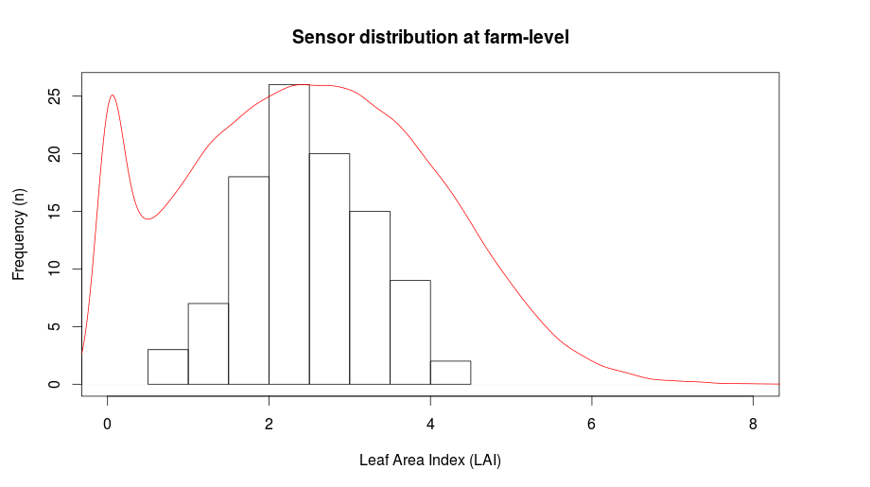
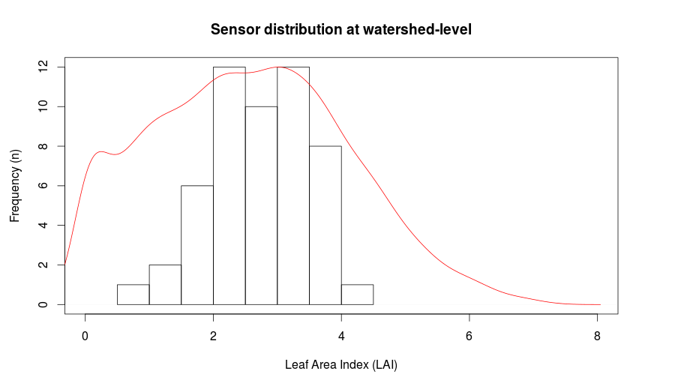

Sampling in Aquiares – Vegetation height

The availability of 2006 data of NASA's Land, Vegetation, and Ice Sensor in the area – which measures both the ground and vegetation height with a scanning laser altimeter instrument – will provide an additional potential co-variable for the temperature and humidity fluctuations in Aquiares. While the data is relatively old (2006), coffee plants can live a long time and are most productive between 7-20 years (ref), this means that the situation in the field will not necessarily have changed a lot. The presence of trees is likely quite similar (although thunderstorms frequently topple trees in the are). Rasters have been created of the study area for both the maximum vegetation height in a certain cell, and the minimum height as calculated in the LVIS image. The minimum has been extracted from the maximum, resulting in a new raster with a mean height difference of 11 meters. The maximum difference is around 81 meters, but each image includes the maximum in a cell, as well as the minimum, which is not necessarily at the same location. The difference between the canopy and ground elevation is an indication of the 'roughness' of the terrain and a larger difference will likely result in more shadow during the day. The larger differences are especially located around the borders. When plotting the altitude of the sensors (25 meter buffer) against the vegetation height, there is not a clear trend, but the larger differences are generally found at the heigher altitudes in the study area.

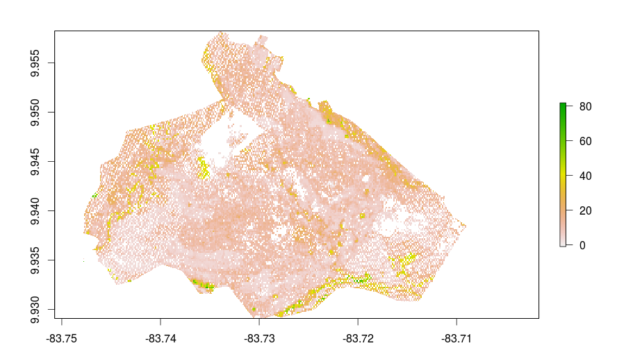
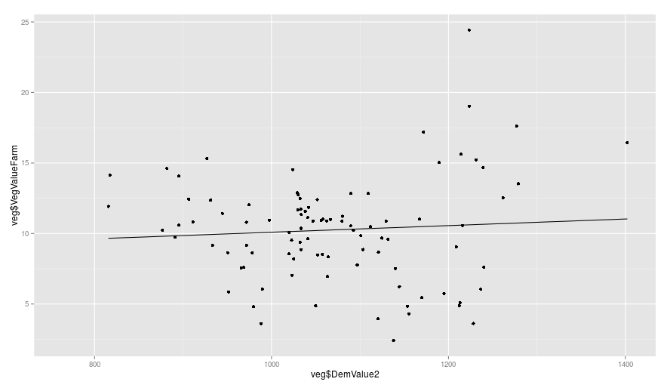
Figure 2: Difference between the canopy height and the ground elevation

http://ip.cals.cornell.edu/undergrad/docs/study-abroad-prog-Aquiares-Estate.pdf
http://www.jstor.org/discover/10.2307/2390210?uid=362989781&uid=3737816&uid=2&uid=3&uid=67&uid=362989631&uid=62&sid=21104516976203
This has been done using the statify function in the spcosa package
http://treephys.oxfordjournals.org/content/26/9/1239.full.pdf

